DIRECT READING USING THE PHILIDELPHIA ROD
As the levelman, you can make direct readings on a self-reading rod held plumb on the point by the rodman. If you are working to tenths of a foot, it is relatively simple to read the footmark below the cross hair and the tenth mark that is closest to the cross hair. If greater precision is required, and you must work to hundredths, the reading is more complicated (see figure 5-10).
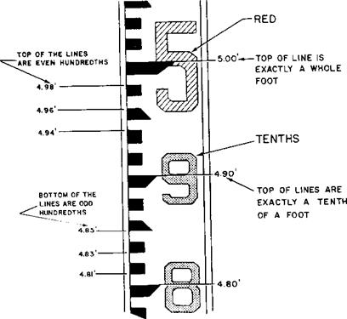
Figure 5-10.—Philadelphia rod marking.

For example, suppose you are making a direct reading that should come out to 5.67 feet. If you are using a Philadelphia rod, the interval between the top and the bottom of each black graduation and the interval between the black graduations (figure 5-11 ) each represent 0.01 foot. For a reading of 5.76 feet, there are three black graduations between the 5.70-foot mark and the 5.76-foot mark. Since there are three graduations, a beginner may have a tendency to misread 5.76 feet as 5.73 feet.
As you can see, neither the 5-foot mark nor the 6-foot mark is shown in figure 5-11. Sighting through the telescope, you might not be able to see the foot marks to which you must refer for the reading. When you cannot see the next lower foot mark through the telescope, it is a good idea to order the rodman to raise the red. On the Philadelphia rod, whole feet numerals are in red. Upon hearing this order, the rodman slowly raises the rod until the next lower red figure comes into view.
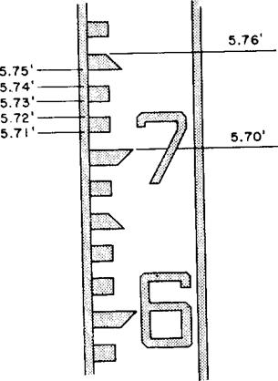
Figure 5-11.—Direct reading of 5.76 ft on Philadelphia rod.

